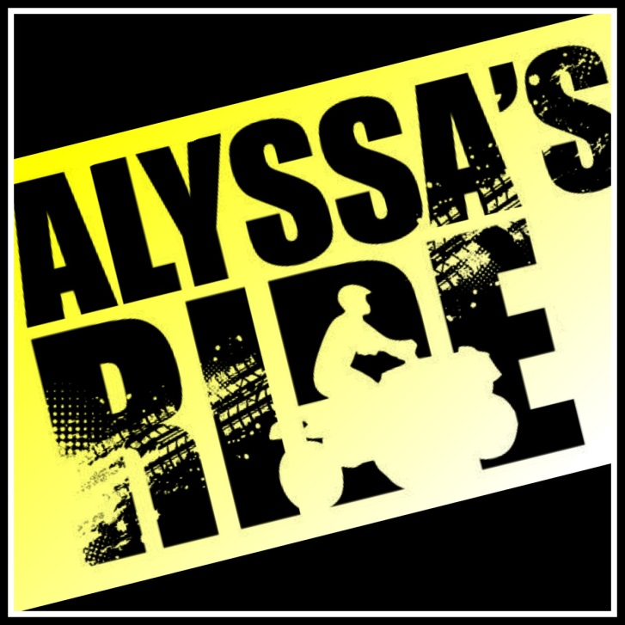**Quantity**

Adult Unisex:

Small x $10 =

Medium x $10 =

Large x $10 =

X-Large x $10 =

2X x $12 =

3X x $14 =

4X x $14 =

Youth Unisex:

Small(6/8) x $10 =

Medium(10/12) x $10 =

Large(14/16) x $10 =

X-Large(18/20) x $10 =

T-shirts will be available on the day of the ride. Please print information clearly, and make check/money order payable to Remembering Alyssa, Inc., P.O. Box 4, Easton, KS 66020.

Name:

Address:

Telephone Number: Email Address: